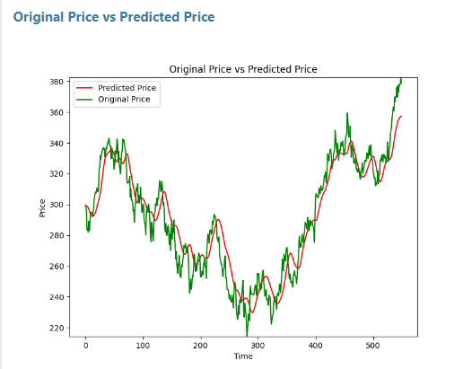

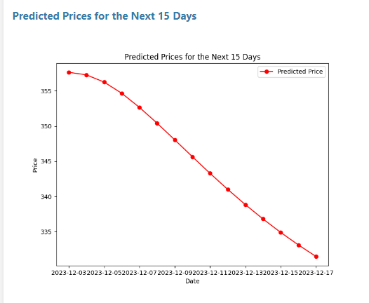

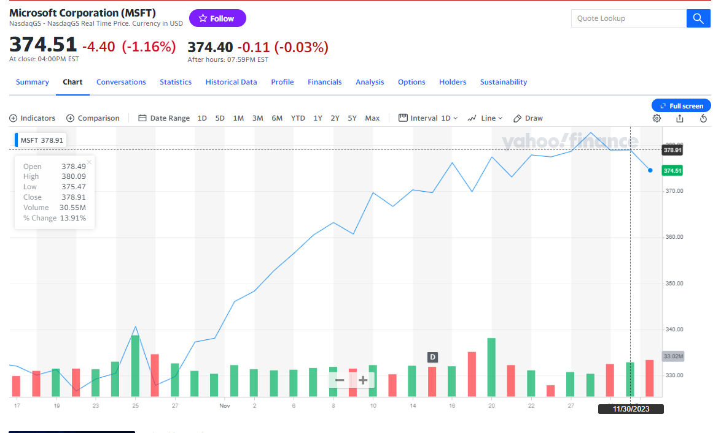

Our model predicted the direction of stock. Here we used MSFT Ticker

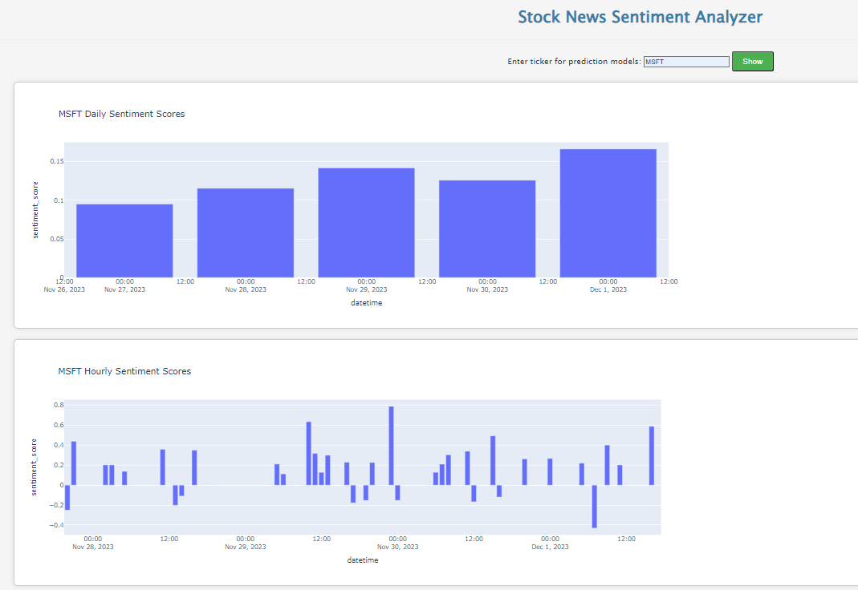

Sentiment of the stock, Here we see positive sentiment.

Based on prediction, Here are the top stocks in our list that will return max prices.

